# **Use App Service Diagnostics**

In this exercise, you’ll use the test app you deployed earlier from GitHub to generate some traffic and analyze problems in App Service Diagnostics.

## **Task 1: Generate Some Traffic**

You’ll need to generate some traffic so that you can analyze it in App Service Diagnostics. There are two options; manually browse to the app a few times or use a free BlazeMeter account to generate some load in Chrome.

I recommend that you use the BlazeMeter option because it will allow you to create much more traffic and generate a more realistic test. However, manually hitting a few URLs will give you enough to see some data in App Service Diagnostics.

**Option 1: Manually Hit Some URLs**

1. Browse to the test Web App you deployed from GitHub earlier.
2. When the app loads, click **About** and wait for the page to load.
3. Click **Contact**.

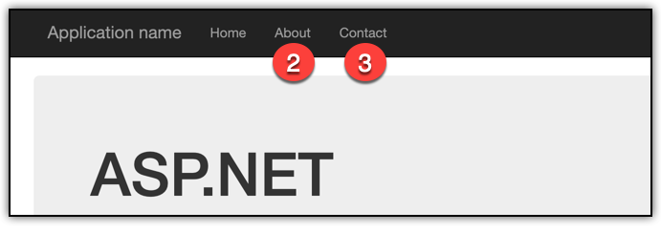

At this point, you should see a generic error page.

1. Click the **Back** button in your browser.
2. Repeat Steps 2-4 a few more times.

**Option 2 (Preferred): Generate Traffic with BlazeMeter**

1. Browse to **www.blazemeter.com**.
2. Click on **Pricing**.

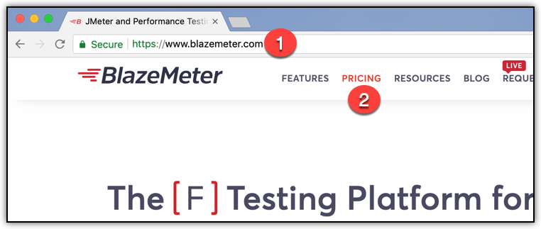

1. Under the Free plan, click on **Sign up for Free** to create a free account.

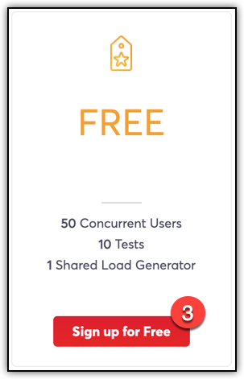

Complete the sign-up process before continuing with Step 4.

1. Browse to **https://chrome.google.com/webstore/category/extensions**.
2. In the Search box, enter **blazemeter** and press Enter to search.
3. Click **Add to Chrome** to add the extension.

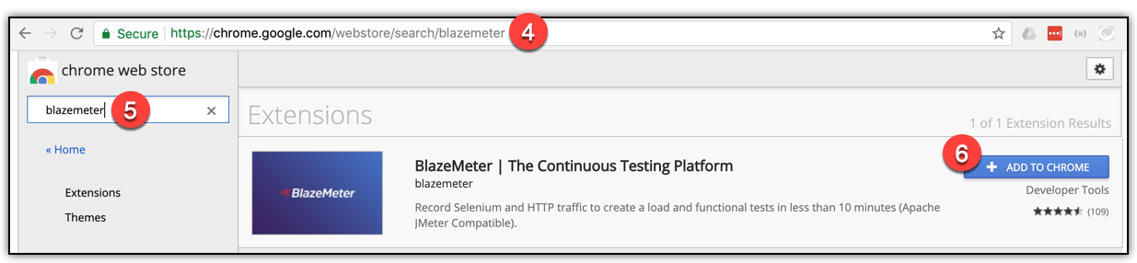

1. Click **Add Extension** to install the extension.



1. Click the icon for the BlazeMeter extension.
2. Click **Login**.

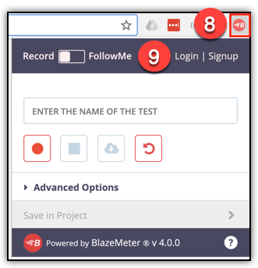

1. Log in using your BlazeMeter account you created in Step 3.
2. Set the toggle switch to **FollowMe**.
3. Enter a name for your test. (This can be anything you’d like.)
4. Choose a **Load Origin**. Ideally, this will be in the same country as the Azure data center where you created your Web App. This will prevent Internet latency from impacting your test.
5. Enter **azurewebsites.net** in the Domains to Follow box. (If you have mapped a custom domain to your app and you want to use that custom domain in your tests, enter that domain instead.)
6. Make sure that **Disable Browser Cache** is checked.
7. Click on Run Test.

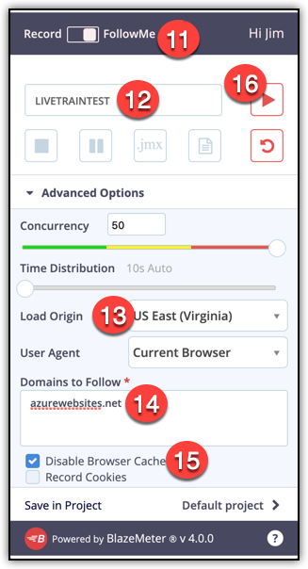

At this point, a new browser tab will open and you’ll see a notice letting you know that BlazeMeter is setting up your test.

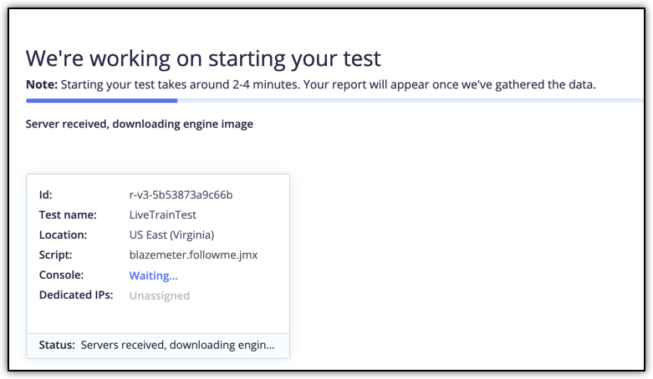

Wait for the **Console** status to change to Ready. You’ll also see a Chrome notification more than likely.

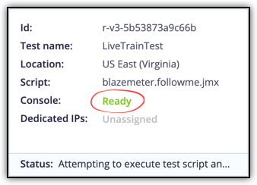

Once the console is ready:

1. Open a new browser tab and browse to your Web App. (Make sure to use the domain you entered when you configured your test in Step 14.)
2. When the site loads, click on **About** and wait for the page to load.
3. Click on **Contact**. You should see a generic error page.
4. Click **Back** in your browser.
5. Click **Home**.
6. Click **About** and wait for the page to load.
7. Click **Contact** and wait for the error page.
8. Click back to the BlazeMeter tab.

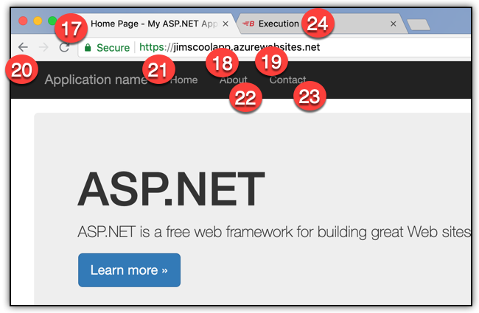

At this point, you want to wait a few minutes for traffic to hit the app. BlazeMeter is hitting your app with many virtual users and you want to let the test run for a few minutes.

1. After a few minutes, click the Stop button on your test. If you’re prompted, click on **Graceful Shutdown**.

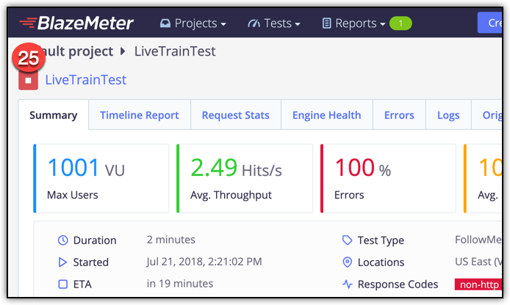

BlazeMeter will show a dialog letting you know that it’s stopping your test. This can take a minute or two, so be patient.

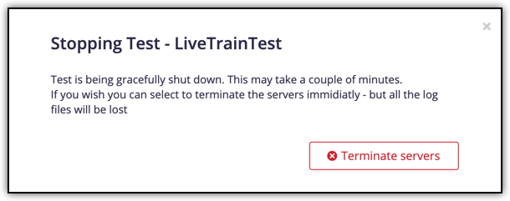

## **Task 2: Analyze Traffic in App Service Diagnostics.**

In this task, you will analyze the traffic you generated in Task 1. Bear in mind that I created traffic with BlazeMeter for the screenshots below. If you manually created traffic, you won’t see as much traffic and problems in the app might not be as obvious to you.

1. Browse to the Azure portal and open your Web App.
2. Click on **Diagnose and Solve Problems** to access App Service Diagnostics.
3. Click **Yes** to run a health check on your Web App.

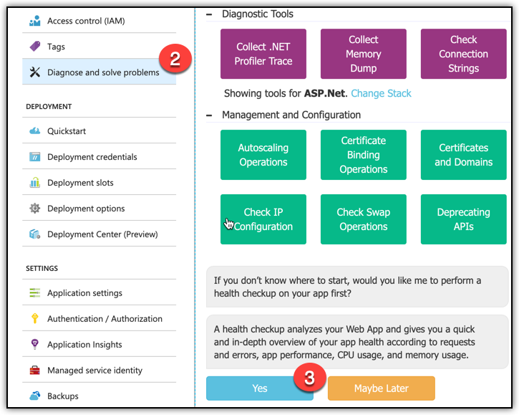

You should see information in App Service Diagnostics that informs you of a problem in the app. Exactly what you see will determine on what’s going on when you clicked to run a health check. If you don’t see a notice of a problem, wait a few minutes, reload App Service Diagnostics in the portal, and run another health check. (There’s about a 10-minute delay between the time traffic hits your site and the data for that traffic is available in App Service Diagnostics.)

Use the various links and reports in App Service Diagnostics to analyze the problem you see. You will certainly see the exception that happened in the Contact link, but you may also see various slow pages. Spend a few minutes reviewing the data App Service Diagnostics provides.

Note that the BlazeMeter account you created during this exercise can be used to create load tests against other sites you manage. You can then use the tools within BlazeMeter to examine issues even if your app is not running in Azure App Service.